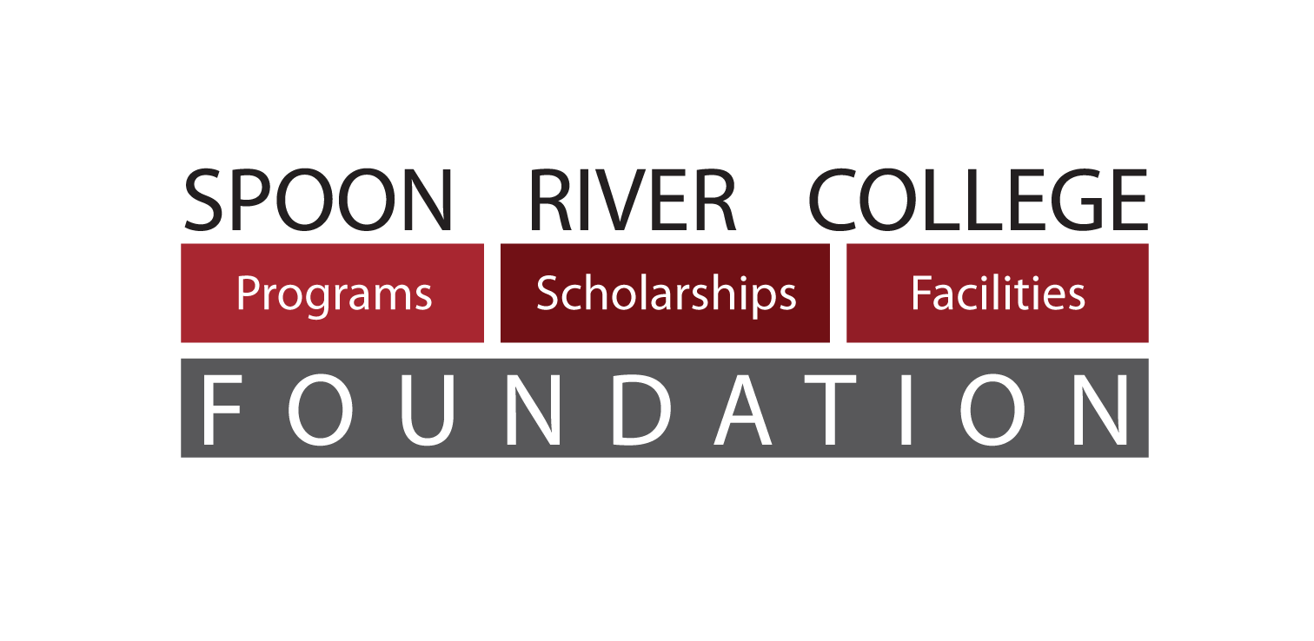
23235 North County Highway 22
Canton, IL 61520
(309) 649-6260
Website: www.src.edu/foundation

Education is the key to a successful future. The Spoon River College Foundation actively seeks resources to provide excellent educational opportunities at Spoon River College.
March 22, 2022

Dear Students (and Parents!),

Congratulations on considering beginning your college education with a dual credit course through Spoon River College. Not only will taking a college-level course now benefit you in the short term, but taking dual credit courses while you are in high school will help you earn college credit at a price that your future self will thank you for!

Attached to this letter is an application for a dual credit scholarship through the SRC Foundation for the Fall 2022 semester. Please note that, to qualify, you’ll need to complete every field and, if you haven’t already, apply for admission to SRC. The application is due by the close of business on July 22, 2022, after which, recipients will be chosen, pending the number of applicants and the availability of funds. We will notify you by mail either way as soon as possible once the recipients are selected. This scholarship will not be applied prior to payment due date. Payment arrangements will need to be made by the payment due date, or the student will be dropped from enrolled courses.

Note that, unless otherwise specified, a dual credit scholarship may only be used for tuition and not books, fees, or other expenses incurred. In addition, the scholarship can only be awarded in the semester in which the SRC grade is awarded. If you are taking a spring semester course, or a year-long course, you are only eligible to apply for a scholarship for the spring semester for that course.

If you would like to learn more about the SRC Foundation, please visit our website at www.src.edu/foundation. Or feel free to contact us at any time at (309) 649-6260. If you have questions specific to dual credit education, please contact Eve Zimmerman at (309) 649-6221.

Again, congratulations on considering dual credit education at SRC! We are confident that you will have a great experience with us, and we hope that you’ll consider more classes with SRC in the future!

Sincerely,
Colin Davis
Executive Director

BOARD OF DIRECTORS

Denise Kirgan
Chair
Nicholas Tinsman
Vice Chair
Zach Maher
Secretary
Staci Mayall
Treasurer
Alan Acheson
Bruce Beal
Brendon Bauman
Glenda Bryan
Debbie Collins
John Davis
Sue Hallmark
Zack Krulac
Laura Leezer
Kathy Lock
Phil Murphy
Sarah Phipps
Mitch Coonradt
Ex-Officio, IPC

SRC PRESIDENT

Curt Oldfield

FOUNDATION STAFF

Colin Davis,
Executive Director
Sarah Gray
Fiscal Officer

Lori Murphy,
Senior Office Assistant

FA22 DUAL CREDIT SCHOLARSHIP APPLICATION FORM
Deadline to submit application for Fall Semester is July 22, 2022
ALL BLANKS MUST BE COMPLETED FOR ELIGIBILITY

Student’s Last Name ______________________ First Name ______________ MI ____
Parent/Guardian Name(s) __________________________________________________
Street Address _______________________________ City/Zip Code _______________
Telephone # _______________________ Student’s Date of Birth *OR* SRC ID ______
# of people in Household _________ Family’s Gross Annual Income __________
# of Dual Credit Courses Being Taken in Fall 2022 ____________________________
Title(s) of SRC Dual Credit Class(es) _________________________________________
Is this your first time taking a Dual Credit Class with SRC? _______ Yes _______ No
NOTE: If yes, you must complete an SRC Admissions Application to be considered for scholarship award. Complete your application here: http://www.src.edu/admissions/Pages/apply.aspx

(To be completed by the student) Below, state why you are requesting financial assistance from the SRC Foundation. Feel free to add a second sheet if necessary.

________________________________________________________________________
________________________________________________________________________
________________________________________________________________________
________________________________________________________________________
________________________________________________________________________

_____________________________ _____________________________
Student Signature Parent/Guardian Signature
For Guidance Counselors:
_____ Most Recent High School Transcript is Attached or On File at SRC (required)
_____ I verify that the above student is enrolled in the above listed dual credit course

___________________________________________________________________
H.S. Counselor (Print & Sign) Name of High School

Return/Mail to: Spoon River College Foundation, 23235 N. County Hwy 22, Canton, IL 61520
or e-mail to foundation@src.edu. Please note that while SRC goes to great lengths to ensure electronic privacy, electronic submission of this application and all the information contained therein is at your own risk.
PLEASE NOTE: This scholarship will not be applied prior to payment due date. Payment arrangements will need to be made by the payment due date, or the student will be dropped from enrolled courses.
If student drops a dual credit course after award is made, the student will be responsible for repaying the scholarship amount to the SRC Foundation. Please visit http://www.src.edu/scholarships for more information.

