The Report on Athletic Program Participation Rates and Financial Support Data (EADA Report)

July 1, 2020 – June 30, 2021
NJCAA Division 2

Number of Full-Time Undergraduate Students by Gender:

This Table shows Fall 2020 semester, 10th day Undergraduate only enrollment numbers. High School dual credit, dual enrollment, and unclassified students are not included.

Athletics Participation

A participant is a student who, as of the day of a varsity team’s first scheduled contest: (a) is listed on the varsity team’s roster; (b) receives athletically related student aid; or (c) practices with the varsity team and receives coaching from one or more varsity coaches. Any student who satisfies one or more of the criteria above is a participant, including a student on a team the institution designates or defines as junior varsity, freshman, or novice, or a student who is withheld from competition to preserve eligibility (i.e., a redshirt), or for academic, medical, or other reasons. Student-athletes who participate in more than one sport are counted in each sport.

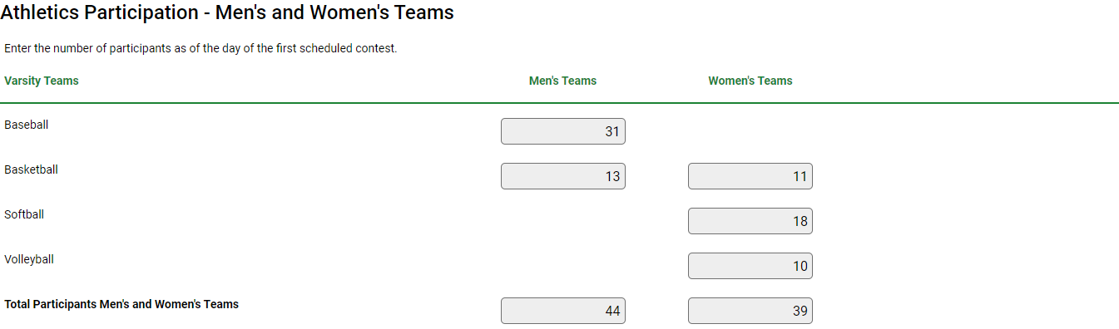

Head Coaches’ Assignments

These tables list the number of head coaches assigned to each team, whether that coach is a male or female, whether that coach is assigned to that team on a full-time or part-time basis, and whether that coach is a full-time or part-time employee of the institution. The table includes paid coaches, volunteer coaches, interns, and graduate assistant coaches. For purposes of this report, the term “Full-Time Coaching Duties” means the individual’s employment responsibilities at the institution are exclusively those as coach of that team, and only that team, and are consistent with the institution’s definition of a full-time employee of the institution or part-time employee of the institution. For purposes of this report, the term “Full-Time Employee” means the individual’s overall employment responsibilities at the institution are consistent with the institution’s definition of a full-time employee although that individual may have responsibilities other than as coach of that team, either within the athletic department or another department of the institution.

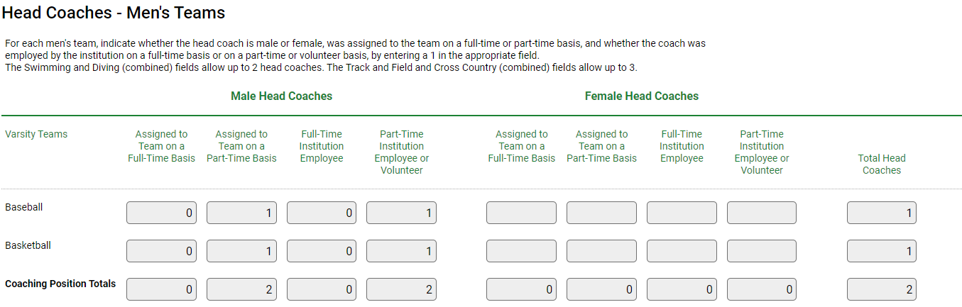

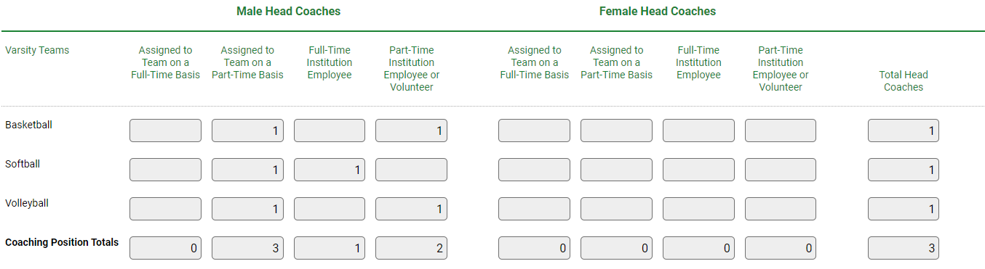

Assistant Coaches’ Assignments

These tables list the number of assistant coaches assigned to each team, whether that coach is a male or female, whether that coach is assigned to that team on a full-time or part-time basis, and whether that coach is a full-time or part-time employee of the institution. The table includes paid coaches, volunteer coaches, interns, and graduate assistant coaches. For purposes of this report, the term “Full-Time Coaching Duties” means the individual’s employment responsibilities at the institution are exclusively those as coach of that team, and only that team, and are consistent with the institution’s definition of a full-time employee of the institution or part-time employee of the institution. For purposes of this report, the term “Full-Time Employee” means the individual’s overall employment responsibilities at the institution are consistent with the institution’s definition of a full-time employee although that individual may have responsibilities other than as coach of that team, either within the athletic department or another department of the institution.

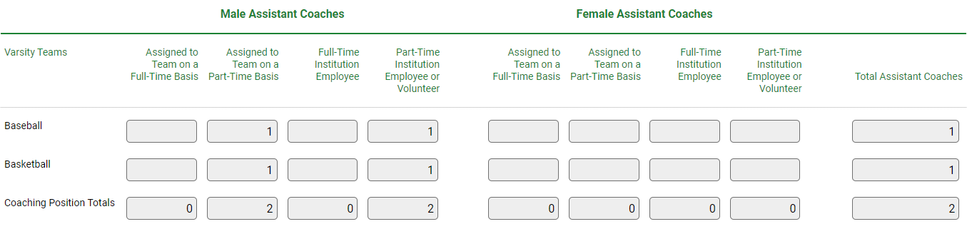
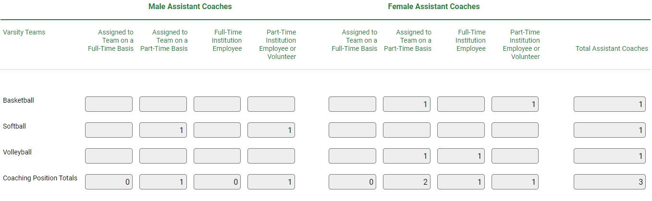
Head Coaches’ Salaries

This table includes only salaries and bonuses paid to head coaches as compensation for coaching. It does not include benefits. Volunteer coaches are not included in calculating the average salary and the Full-Time Equivalent (FTE) Total.

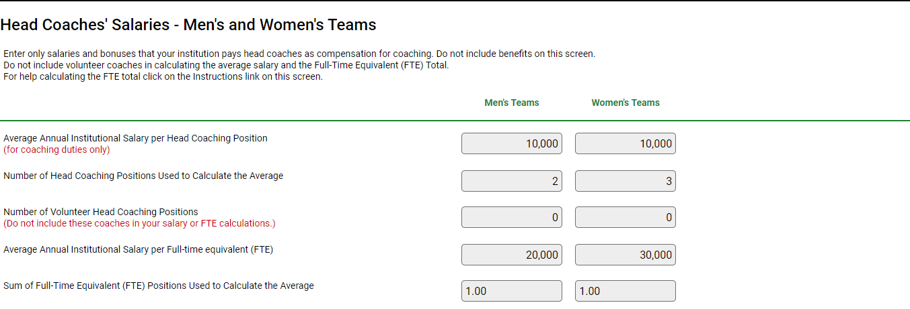
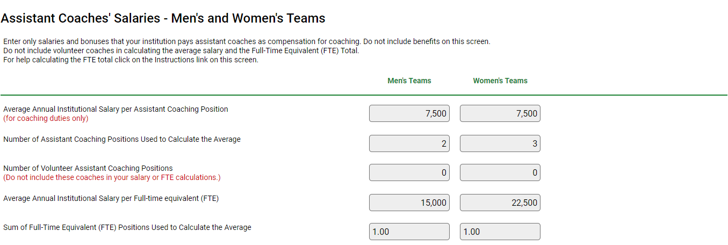
Athletically Related Student Aid

Athletically related student aid is any scholarship, grant, or other form of financial assistance, offered by an institution, the terms of which require the recipient to participate in a program of intercollegiate athletics at the institution. Other student aid, of which a student-athlete simply happens to be the recipient, is not athletically related student aid.

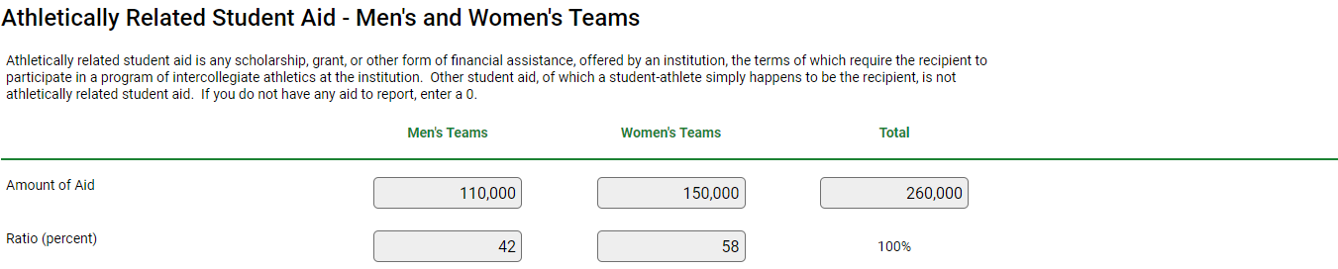

Athletic Operating Expenses

Athletic Operating expenses include all expenses an institution incurs attributable to home, away, and neutral-site intercollegiate athletic contests (commonly known as “game-day expenses”), for (A) Lodging, meals, transportation, uniforms, and equipment for coaches, team members, support staff (including, but not limited to team managers and trainers), and others; and (B) Officials.

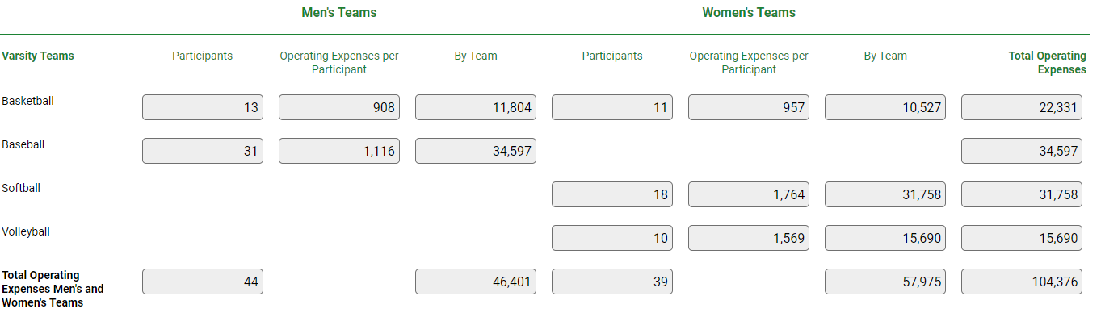

Total Expenses

Total Expenses are all expenses attributable to intercollegiate athletic activities. These include appearance guarantees and options, athletically related student aid, contract services, equipment, fundraising activities, operating expenses i.e.(game-day expenses), promotional activities, recruiting expenses, salaries and benefits, supplies, travel, and any other expenses attributable to intercollegiate athletic activities.

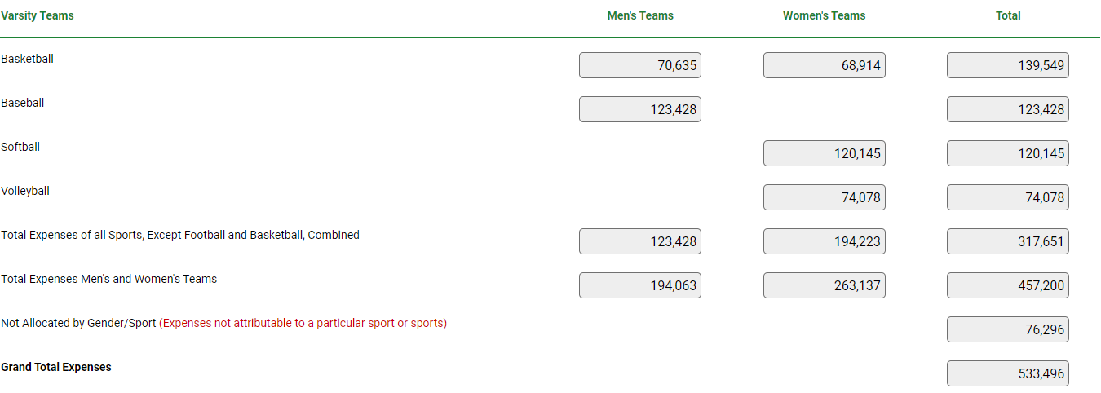

Total Revenues

Total Revenues are all revenues attributable to intercollegiate athletic activities. This means revenues from appearance guarantees and options, an athletic conference, tournament or bowl games, concessions, contributions from alumni and others, institutional support, program advertising and sales, radio and television, royalties, signage and other sponsorships, sports camps, State or other government support, student activity fees, ticket and luxury box sales, and any other revenues attributable to intercollegiate athletic activities.

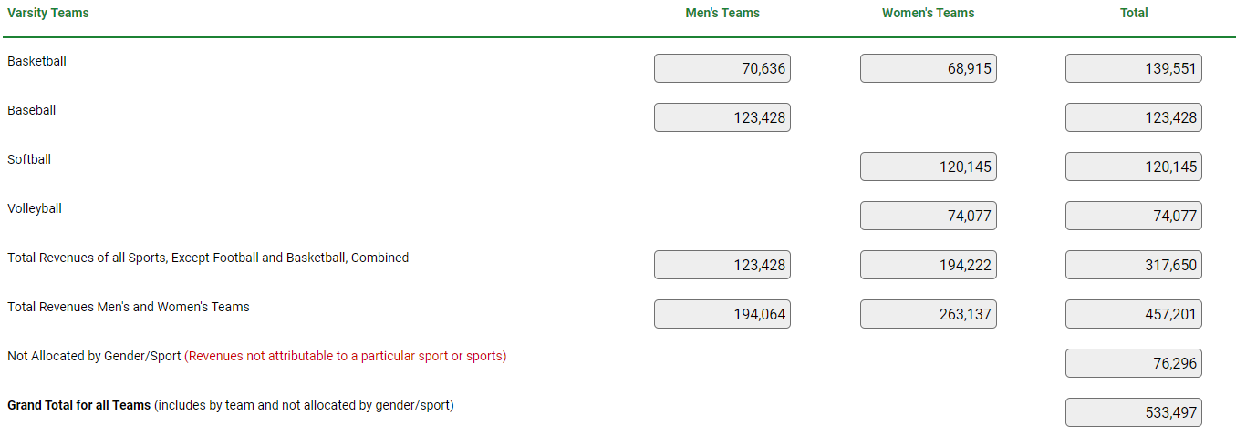

Summary

