Next Generation Accuplacer Test Student Guide
What is Next Generation Accuplacer?
Spoon River College uses a computer-based placement test called Next Generation Accuplacer. Students will be assessed in writing, reading and math. Although testing is done on a computer, no computer experience is required. Directions are clearly stated, and help is always available. With the exception of the essay portion on the test (60 minutes) there is no time limit so you should work carefully and at your own pace. Each Next Generation Accuplacer test section has a designated number of questions: Reading Comprehension (20 questions), Writing Test (25 questions), and Quantitative Reasoning, Algebra and Statistics Math Test (20 questions). Students may be required to take all or only part of the Next Generation Accuplacer based on a review of their high school transcript, ACT, and/or SAT scores.

Why do I need to take Next Generation Accuplacer?
Spoon River College students arrive on campus with varied skill levels and life experiences. Students come to us directly from high school, from other colleges, and from work-related backgrounds. In order to give students the best opportunity for academic success, students and advisors need to know current levels of achievement, and Next Generation Accuplacer gives that needed information. The goal of the assessment is to place students in the correct courses according to their current academic achievement levels.

Spoon River College is using a multiple measure system for placement. This means that SRC may also use ACT, SAT, and/or high school transcripts for placement. Students must meet required scores on the ACT or SAT to be exempt from Next Generation Accuplacer testing. High school transcripts that indicate a student has earned a “B” or better in Algebra II and Geometry or a higher level math may be exempt from taking the math portion of the test. High school GPA may be used to determine placement into English courses. Placement requirements in each of these areas can be found in the chart below.

How are the Next Generation Accuplacer scores used?
The Next Generation ACCUPLACER is graded on a scale of 200-300. Because the test helps determine whether you are ready for college-level courses, a student cannot pass or fail the examination. Depending on how you score, you may be required to take developmental course to help prepare you for college-level courses. Scores are available as soon as testing is completed. Test results help you and your academic advisor select classes and plan an appropriate course of study. The tests are not used to determine admission to the college and there is no charge for the test. However, a $5.00 retest fee per test portion will apply if you were not happy with the first set of results.
How can I prepare for the Next Generation Accuplacer?
The best way to prepare for the Next Generation Accuplacer is to review sample questions at the following website:
http://accuplacerpractice.collegeboard.org.

Next Generation Accuplacer Reading Test (20 questions)
Four broad knowledge and skill categories are assessed: 1-Information and Ideas (reading closely, determining central ideas and themes, summarizing, understanding relationships) 2-Rhetoric (analyzing word choice rhetorically, analyzing text structure, analyzing point of view, analyzing purpose, analyzing arguments) 3-Synthesis (analyzing multiple texts), and 4- Vocabulary.
Next Generation Accuplacer Writing Test (25 questions)
Evaluates a test-taker’s ability to revise and edit multi-paragraph text. Questions cover two broad knowledge and skills categories, each containing three subcategories: Expression of Ideas including development, organization and effective language use, and Standard English Conventions like sentence structure, usage and punctuation. Students also have the option of taking the WritePlacer test which requires the student to write an essay based on a given prompt within a 60 minute time frame.
Next Generation Accuplacer Quantatitive Reasoning, Algebra and Statistics Mathematics Test (20 questions)
Next-Generation Quantitative Reasoning, Algebra, and Statistics (QAS) test assesses the following knowledge and skills: Rational numbers, Ratio and Proportional Relationships, Exponents, Algebraic Expressions, Linear Equations, Linear Applications and Graphs, Probability Sets, Descriptive Statistics and Geometry Concepts.

The following information will help you have a positive Next Generation Accuplacer test experience:

- Allow about 1½ to 2 hours to take the test. However, it is not a timed test except for the essay writing portion (60 minutes).
- Cellular phones, tablets, pagers, smartphones, walkie-talkies, PDAs, wireless communication devices, digital watches, smartwatches, or wristwatch cameras are not allowed in testing room.
- No food or drinks allowed in the testing area.
- Please leave children at home and plan on a babysitter if needed.
- Bring photo id and know your SRC student ID number.
- Be rested and ready to concentrate.
- Answer each question carefully.
- Take a break between tests, if necessary.
- Ask the test administrator for help if you are unsure about directions.
- Don’t be concerned if others finish before you. Remember, other students may be taking different portions of the exam than you are, and people finish testing at different times.
- Plan to do your best the first time you test. If, however, you feel your placement does not reflect your true ability, you may retest one time before taking classes in the subject area. There will be a $5.00 retest fee per portion of the test repeated.
- Students with special needs or students with special testing considerations should contact the Disability Services Advisor prior to testing. Students may phone 309-649-6305 to talk about possible testing accommodations.

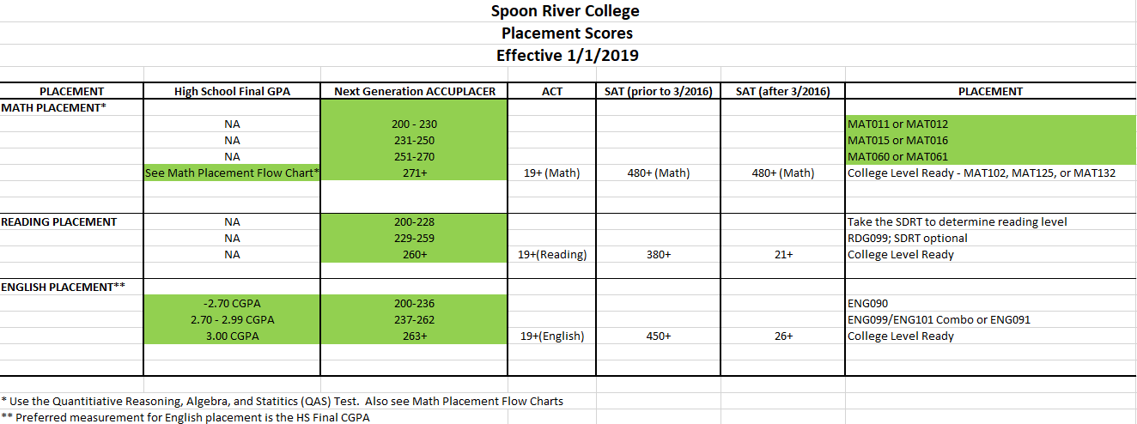

WHEN AND WHERE CAN I TEST?
Testing is done on a walk-in basis from 8:00 a.m.-3:00 p.m. in the Student Services Department at Spoon River College Canton and Macomb sites. Please call the Rushville or Havana sites to set up an appointment during their regular office hours (8:00 a.m-4:30 p.m.) at the numbers listed below.
CANTON 309-649-6400 MACOMB 309-833-6069 RUSHVILLE 217-322-6060 HAVANA 309-543-4413

